Healthy Eating

The Eatwell Plate is a useful tool to help achieve a balanced, healthy diet. The plate shows the proportion that each of the five food groups should be included in the diet. Fruits and vegetables should make up a third of the diet, as should starchy foods such as bread, potatoes, pasta and rice. Wholegrain starchy foods, such as wholemeal bread, are recommended as these contain more fibre.
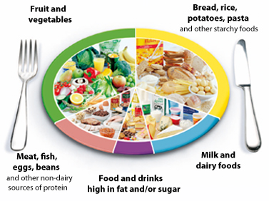
NHS Choices is a recommended website to learn more about healthy eating.
The proportions of each of the food groups may be changed in accordance with specific dietary needs. For example, residents at risk of malnutrition may have a larger proportion of high fat and high sugar foods and dairy foods in their diet.
Menus
A balanced and nutritious menu will ensure residents receive all the nutrients they require to keep healthy and avoid deficiencies. The following guidelines are recommended by the South Warwickshire NHS Foundation Trust Dietetic Department to help plan your menus:
Eating Well: Supporting Older People and Older People with Dementia
Menu Planning and Special Diets in Care Homes
Prevention and Treatment of Malnutrition
More than one in three people admitted to care homes are at risk of malnutrition (BAPEN, 2012). Malnutrition may result in:
- Increased risk of getting infections
- Poor wound healing
- Increased risk of having a fall
- Increased risk of admission to hospital
- Low mood
It is important that all residents are screened for risk of malnutrition when they are admitted and then on a monthly basis. The screening tool that is recommended in Warwickshire is the Malnutrition Universal Screening Tool (MUST). See www.bapen.org.uk/screening-for-malnutrition/must/introducing-must for more details or contact your local dietetic department.
The South Warwickshire NHS Foundation Trust Dietetic Department have produced a set of guidelines that provide suggested actions that can be put in place for residents that are found to be at risk of malnutrition. Contact your local dietetic department for more information.
Dysphagia
- Modified Consistency Diets
In 2011, the descriptors for the different textures of diet were revised. The following document details each of the textures and provides an audit checklist so that you can ensure your meals are the correct consistency:
Dysphagia Diet Food Texture Descriptors
- Home Enteral Tube Feeding
For information regarding tube feeding, such as nasogastric and gastrostomy feeding, please contact your local dietetic department.
Diabetes
For up to date information about diabetes, the Diabetes UK website is recommended. The following set of guidelines is of particular relevance for care homes:
Good clinical practice guidelines for care home residents with diabetes

